# ***ASSINGNMENT***

**MODULE-1: UNDERSTANDING OF HARDWARE AND ITS COMPONENTS**

**SECTION 1: MULTIPLE CHOICE**

**1. Which of the following is NOT a component of the CPU?**

* . RAM

2**. What is the function of RAM in a computer?**

* RAM full form Random access memory, Ram is volatile, it loses its contents when the computer power goes off or restarted.

**Its Functions are**

* Storage of ta and instructions during computer operations
* Facilitation of quick access to data for the CPU
* Temporary storage of data for running programs
* Enhancement of overall system performance.

3. **Which of the following is a primary storage device?**

* 4.1 and 2 both (HDD,SSD)

4. **What is the purpose of a GPU?**

* GPU full form is a GRAPHICS PROCESSING UNIT. GPU is a computer chip that renders graphics and images by performing fast mathematical calculations. Uses of GPU for Gaming, video Editing, 3D Graphics Rendering, Machine learning etc.

**SECTION 2: TRUE OR FALSE**

5**. The motherboard is the main circuit board of a computer where other components are attached.**

* TRUE

**6. A UPS (Uninterruptible Power supply) is a hardware device that provides emergency power to a load when the input power source fails.**

* TRUE

**7. An expansion card is a circuit board that enhances the functionality of a computers**.

* TRUE

**SECTION 3: SHORT ANSWER**

8. **Explain the difference between HDD AND SSD**.

|  |  |
| --- | --- |
| * HDD | * SSD |
| * It’s full form of HARD DISK DRIVE | * It’s full form solid state drive |
| * It’s utilize as PATA, SATA and SCSI. | * It’s utilize as NVMe interface |
| * It’s not new, you will find them installed in older computer. | * It’s one of the latest hard drive technology at the time, find in new computer. |
| * They consist of a moving parts that rotates during reading and writing operations. So they usually make noise. | * They don’t consist of moving parts and they don’t use magnetism for storing data, so they don’t make noise. |
| * They use MAGNETISM | * They use (ICs) INTEGRATED CIRCUITS |

9. **Describe the function of BIOS in computer system.**

* BIOS full form of Basic input-output system.
* BIOS is firmware software or program, it is store booting information and configuration of computer devices.
* It is a firmware used to initialize and Test system hardware components and load an operating.
* Types of BIOS

1. LEGACY
2. UEFI (Unified Extensible firmware interface).

10**. List and briefly explain three input devices commonly used with computers.**

* LIST OF INPUT DEVICES ARE

1. KEYBOARD
2. MOUSE
3. JOYSTICS
4. SCANNAR
5. TRACK BALL
6. LIGHT PEN
7. MICROPHONE, etc.
8. **Keyboard**

* It is the most common and popular input device which helps in inputting data to the computer. The layout of the keyboard is like that of traditional typewriter, there are some additional keys provided for performing additional fuctions.
* Keyboards are of two sizes 84 keys or 101/102 keys, but now keyboards with 104 keys or 108 keys are also available for windows and internet.
* **Types of keyboard**

1. STANDARD KEYBOARD (104 keys)
2. LAPTOP KEYBOARD
3. GAMING KEYBOARD
4. LASER OR INFRARED KEYBOARD
5. ROLL UP KEYBOARD
6. STANDARD KEYBOARD

* It also known as the desktop keyboards, include alphabetic characters, punctuation symbols, numbers and a variety of function keys.

1. LAPTOP KEYBOARD

* Has the same keyboard type as a normal keyboard, except for the fact that most laptop keyboard condense the symbols into fewer buttons to accommodate less space.

1. GAMING KEYBOARD

* Are similar to normal keyboard except they generally contain features such as illuminated LCD screen, palm rest and other features.

1. LASER AND INFRARED KEYBOARD

* This device projects the keyboard on to a flat surface, such as a table or desk.

1. ROLL UP KEYBOARD

* Are made of soft plastic or silicone which can be rolled on itself for travel.
* **Connection type of keyboard**

1. Wired keyboard
2. Ps/2
3. USB
4. Wireless keyboard
5. Bluetooth
6. Infrared(IR)
7. Radio frequency.
8. **MOUSE**

* A mouse is a small input device, It is used to control the computer when we move the mouse around on a table the pointer on the screen also moves. There are a left click or right click, scrolling button.
* **Types of mouse**

1. MECHANICAL MOUSE
2. OPTO-MECHANICAL MOUSE
3. OPTICAL-MOUSE
4. TRACKBALL-MOUSE
5. TRACK-POINT MOUSE
6. TOUCH-PAID MOUSE
7. ERGONOMIC MOUSE (WIRELESS)
8. MECHANICAL MOUSE

* It contains a rotating ball on the bottom and attached with a cord to system unit.
* As it moves the roller rotates and control the pointer on the monitor.

1. OPTO-MECHANICAL MOUSE

* It is also known as the ball mouse.
* It has two internal wheels that are each moved by a ball.
* There is allowing led light to shine though and picked up by a sensor.

1. OPTICAL MOUSE

* It uses an LED light and sensor to detect movement

1. TRACKBALL MOUSE

* It has features a ball that user rotates to move the cursor, reducing the need for large movements.

1. TRACK-POINT

* It has small joystick like device typically found on laptops, used to control the cursor.

1. TOUCHPAD MOUSE

* It is built in input device on laptops, uses touch gestures to control the cursor.

1. ERGONOMIC MOUSE

* It is designed to minimize strain on the hand, wrist, and arm, often with a vertical or sculpted shape.

1. LIGHT PEN

* Light pen is a pointing device which is similar to a pen. It used to select a displayed item or draw pictures on the monitor screen. It consists of photocell and an optical system placed in small tube. When then tip of a light pen is moved over the monitor screen and pen button is pressed, it photocell sensing element detects the screen location and sends the corresponding signal to the CPU.

**SECTION 4: PRACTICAL APPLICATION**

11**. Identify and label the following components on a diagram of a motherboard:**

* CPU
* RAM slots
* SATA connectors
* PCI-E slot

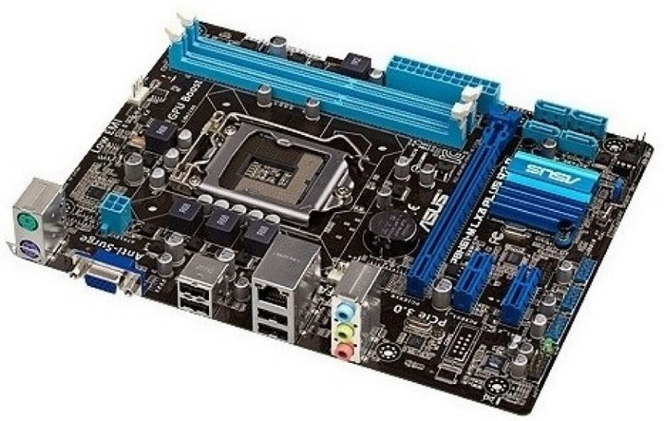

**CPU** **RAM slots** **SATA connectors** **PCI-E slot**

12. **Demonstrate how to install a RAM module into a computer.**

* For installation RAM we following below steps.

STEP 1. At first, before open cabinet, close all running programs and go start menu and right click on start menu select shut down and also use short cut keys “ window+alt+f4” for shut down

STEP 2. We need to do switch off the power cable connection & remove all the power cables connection from the plug point. After 5 seconds press the power button, it will remove the remaining electricity from the device.

STEP 3. Now we need to do open the cabinet using screwdriver & place it on the ground, remove step by step all hardware components like SMPs, hard disk and SSD, and motherboard .we check all components properly and beside CPU-FAN locate RAM module slot there we can unlock RAM slot and fit RAM and lock RAM slot and again assemble step by step cabinet.

Here, we have successfully inserted RAM on the computer.

**SECTION 5: ESSAY**

**13**. **Discuss the importance of proper cooling mechanisms in a computer system. Include examples of cooling methods and their effectiveness.**

* Proper cooling mechanisms is very important in a computer system because todays demanding workload in industry, gaming zone and also long terms use of PC in personal life so result is hardware generating more heat . Overheating components give low performance and computer working slowly so we need to do our hardware components sufficiently cool and we get the best performance from our PC.